GLOBAL AI AND DATA SCIENCE JOBS ANALYSIS: TRENDS, SKILLS DEMAND, AND SALARY INSIGHTS

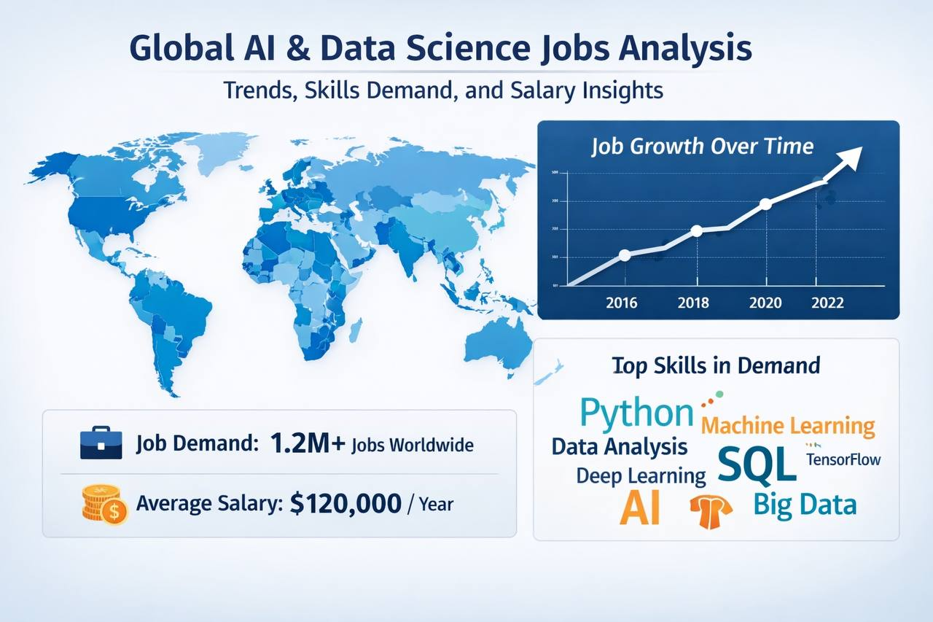

INTRODUCTION
The rapid growth of Artificial Intelligence and Data Science has transformed the global job market, creating high demand for skilled professionals across industries. This project explores global job trends in AI and Data Science by analyzing key factors such as job roles, required skills, salary distribution, and hiring patterns.
The goal of this analysis is to uncover actionable insights that can guide aspiring professionals, recruiters, and organizations in making data-driven career and hiring decisions.

ABOUT THE DATASET
The dataset consists of over 10,000 job listings in the AI and Data Science domain, covering multiple countries and industries. It provides a comprehensive view of the global AI and Data Science job landscape.
Key features include:
- Job roles (e.g., Data Scientist, AI Engineer, Business Analyst)
- Company size and industry
- Geographic location (countries)
- Experience level and years of experience
- Educational requirements
- Technical skills (Python, SQL, Machine Learning, Deep Learning, Cloud)
- Salary information
- Job posting timeline (month and year)
- Hiring urgency and number of openings

PROBLEM STATEMENT
Despite the growing interest in AI and Data Science careers, many professionals lack clarity on:
- Which roles are most in demand globally
- What skills are most required by employers
- How salaries vary across roles and regions
- Hiring trends and urgency in the job market
This project aims to bridge that gap by analyzing real-world job data to identify patterns, trends, and opportunities in the industry.

VISUALIZATION
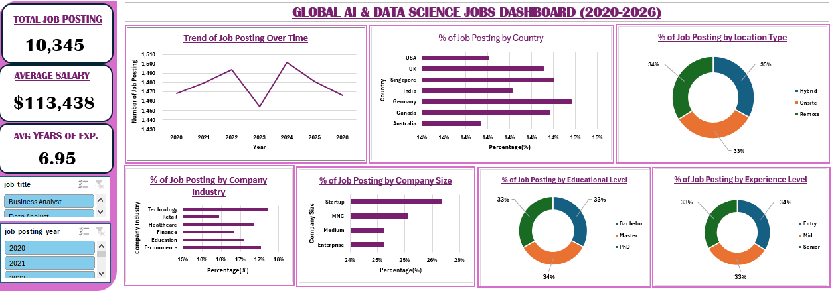
To interact with dashboard, click here

INSIGHTS
From the analysis, several key insights emerged:
- High Demand Roles:
Business Analyst, Data Scientist, and Machine Learning Engineer roles dominate the job market.
- Global Opportunities:
Countries like Germany, Singapore, Canada, the UK, and India show consistently high job postings, indicating strong demand across both developed and emerging markets.
- Salary Trends:
  - Average salary: ~$113,000
  - Highest salaries exceed $200,000, typically for advanced or specialized roles
  - Salary increases with experience and technical specialization
- Skill Demand:
  - Core skills such as Python, SQL, Machine Learning, Cloud, and Deep Learning are almost equally in demand
  - Cloud and Machine Learning show slightly higher demand, reflecting industry shift toward scalable AI systems
- Hiring Urgency:
A significant portion of roles are marked as high urgency, indicating a talent shortage in the field.
- Job Openings:
Most listings have multiple openings (average ≈ 5), reinforcing strong demand for talent.

RECOMMENDATION
For Job Seekers:
- Focus on core technical skills: Python, SQL, Machine Learning, and Cloud computing
- Gain practical experience through projects and certifications
- Target high-demand roles like Data Scientist and ML Engineer
For Recruiters/Organizations:
- Invest in talent development and training programs
- Offer competitive salaries to attract top talent
- Expand hiring globally to access a wider talent pool
For Educators:
- Align curriculum with industry-relevant skills, especially ML and Cloud technologies
- Emphasize hands-on, project-based learning

CONCLUSION
This analysis highlights the strong global demand for AI and Data Science professionals, driven by rapid technological advancement and digital transformation across industries.
The findings show that while opportunities are abundant, success in this field requires a strategic focus on in-demand skills and continuous learning. By leveraging these insights, stakeholders can make informed decisions to thrive in the evolving data-driven economy.

